Contents
1 Introduction 1
2 Objectives 1
3 Technology Stack 1
4 Architectural Style 2
5 High-Level System Architecture 2
5.1 Components 2
5.2 Architecture Diagram (Logical View) 2
5.3 Backend Architecture 3
5.4 Frontend Architecture 3
6 Data Flow Diagrams 3
Product Search Flow 3
7 Database Design 3
8 Security 4
9 Scalability 5
10 Deployment Architecture 5
11 Future Enhancements 5
12 Conclusion 5

Introduction
The Smart Shopping Cart Application is a small-scale e-commerce web application designed to demonstrate architectural design principles, scalability considerations, and modern development best practices. The system enables users to browse products, perform advanced searches, manage a shopping cart, and receive product recommendations.

Objectives
- Demonstrate clean system architecture
- Support scalability and performance
- Implement advanced search and recommendations
- Use modern frontend and backend technologies

Technology Stack
Frontend
- ReactJS
- Redux Toolkit
- HTML, CSS, JavaScript
- Local Storage (Cart Persistence)
Backend
- .NET Core Web API
- Swagger for API documentation
- Dapper for micro ORM
- Redis (Caching) for faster search result
- Docker for Redis
DB
- MS SQL Server

Architectural Style
Chosen Architecture Rationale for Monolith API
- Suitable for small to medium-scale applications
- Simpler deployment compared to microservices

High-Level System Architecture

Technical Components
- React Frontend Application
- .NET Core Backend API
- Redis Cache
- MS SQL Server Database

Architecture Diagram

Logical View
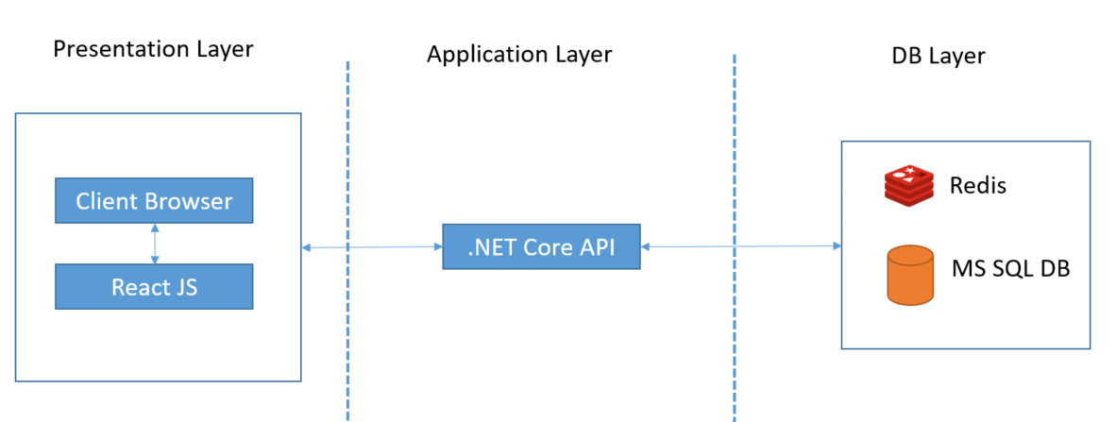

Components View
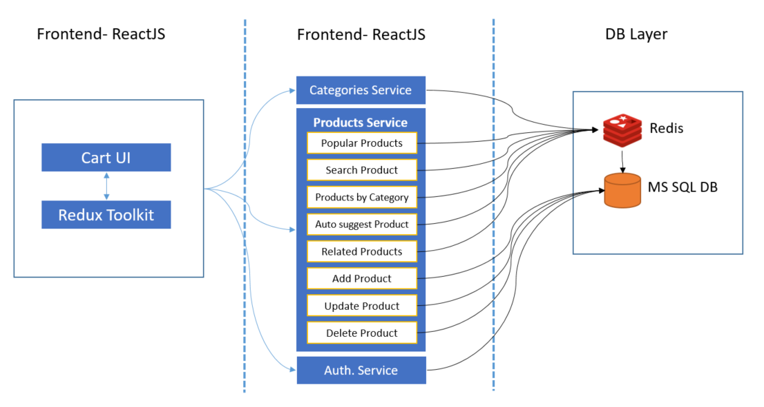

Sequence/Dataflow diagram
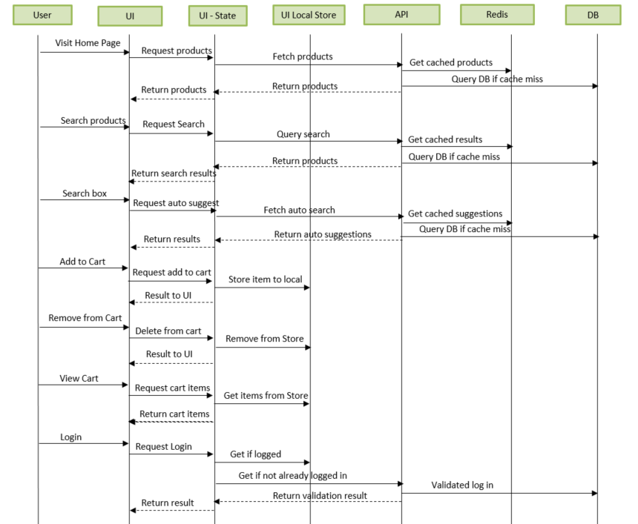
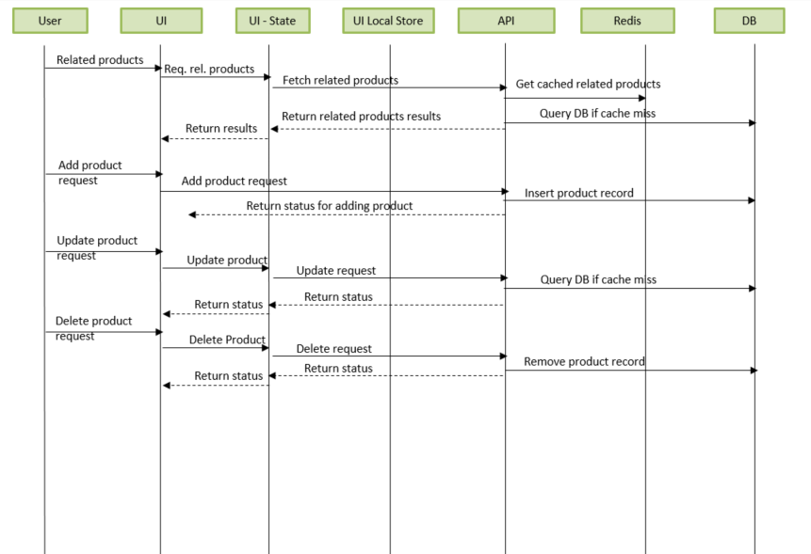

Database Design

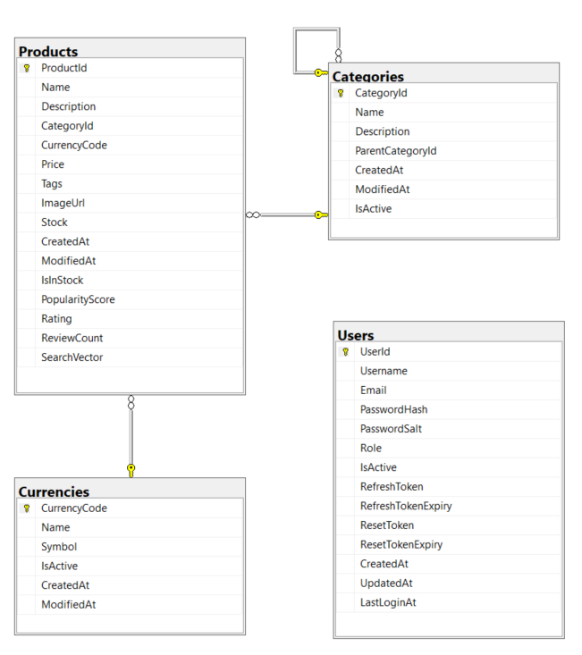

Security
- Role based UI component rendering
- JWT Authentication (Optional)
- Role-based authorization
- Input validation and sanitization

Scalability
- Stateless backend APIs
- Horizontal scaling supported
- Redis shared cache
- SQL Server read scalability

Deployment Architecture
Docker Containers
- React Frontend
- .NET Core API
- Redis
- SQL Server

Future Enhancements
- Migration to Microservices
- Bulk update/add of products
- Elastic search integration
- AI-based recommendations
- Payment gateway

Conclusion
The Smart Shopping Cart Application architecture ensures scalability, maintainability, and performance while maintaining simplicity. The chosen modular monolith architecture aligns well with current requirements and allows future expansion.

